RANDOM CONTROLLER :

Adding thread group to test plan by right click on test plan then click on add, then click on thread and then click on thread group.

Giving name as Random Controller Thread Group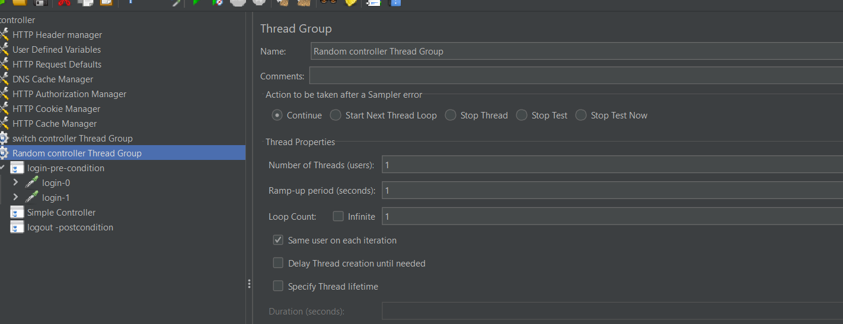

Adding Random controller in logic controller

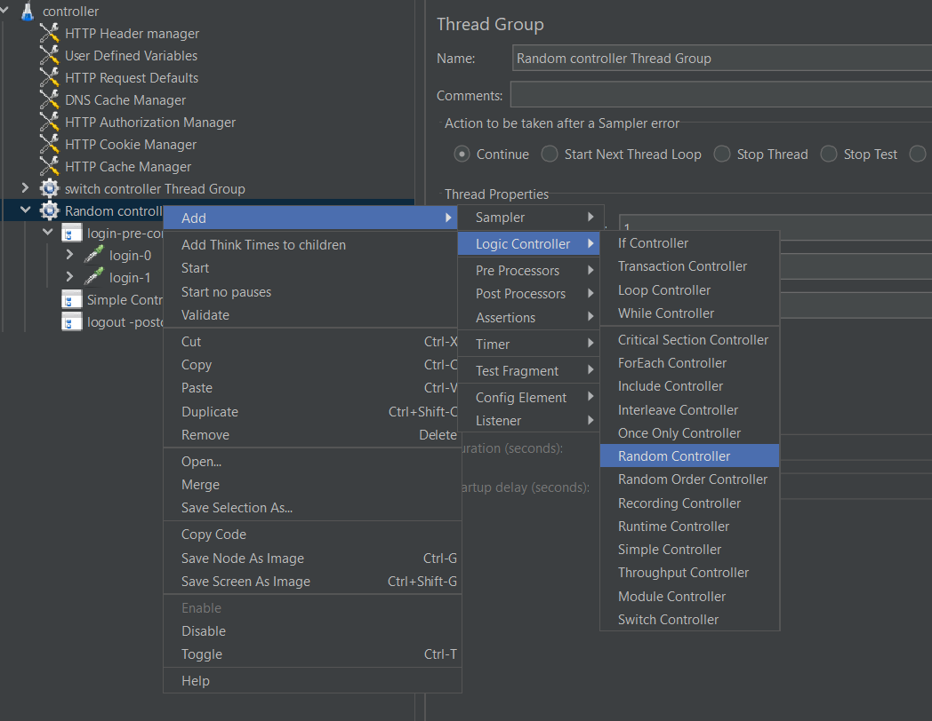

Adding simple controller inside the Random controller ,and paste the scripts in it.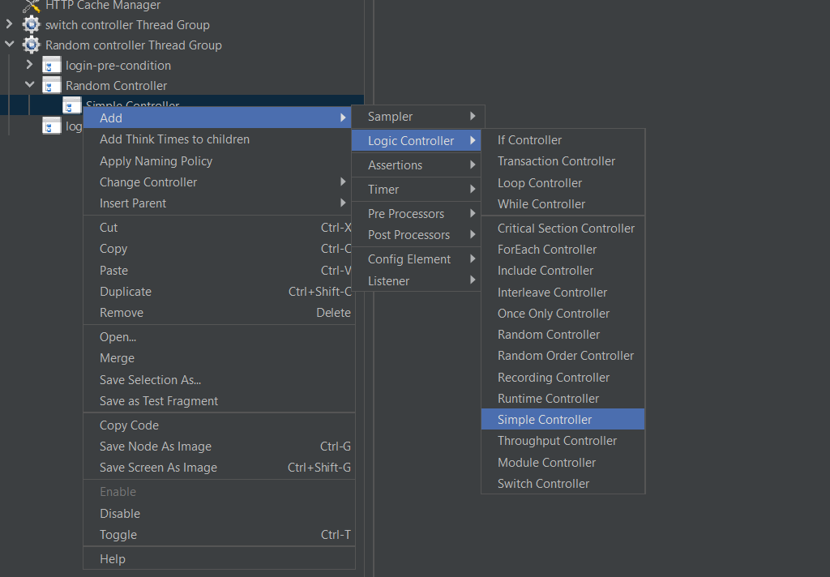

Adding listeners to view the result

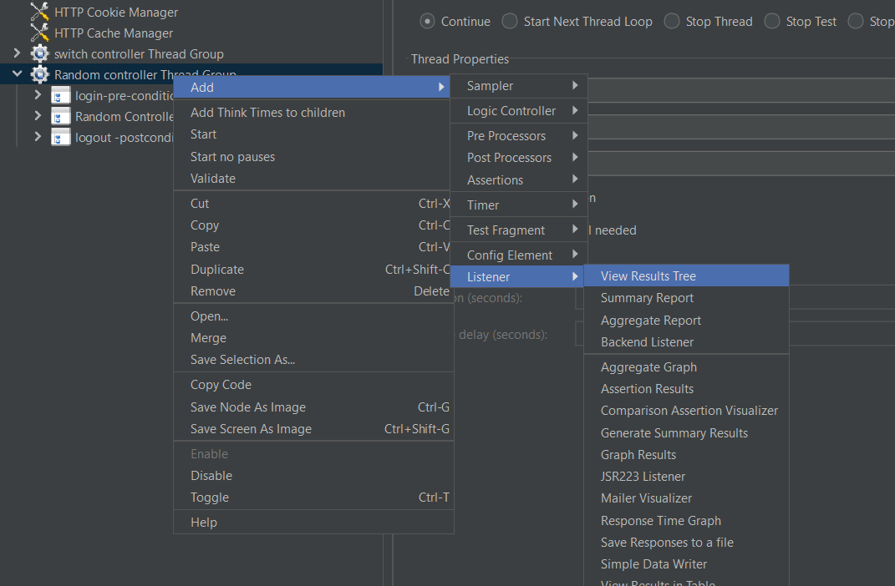

Giving loop count -03 in Thread-group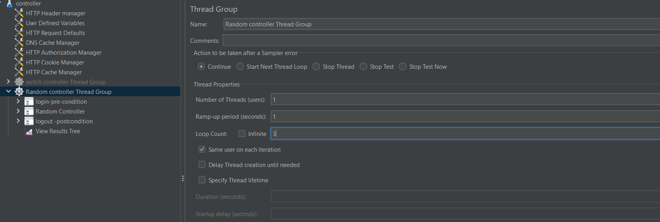

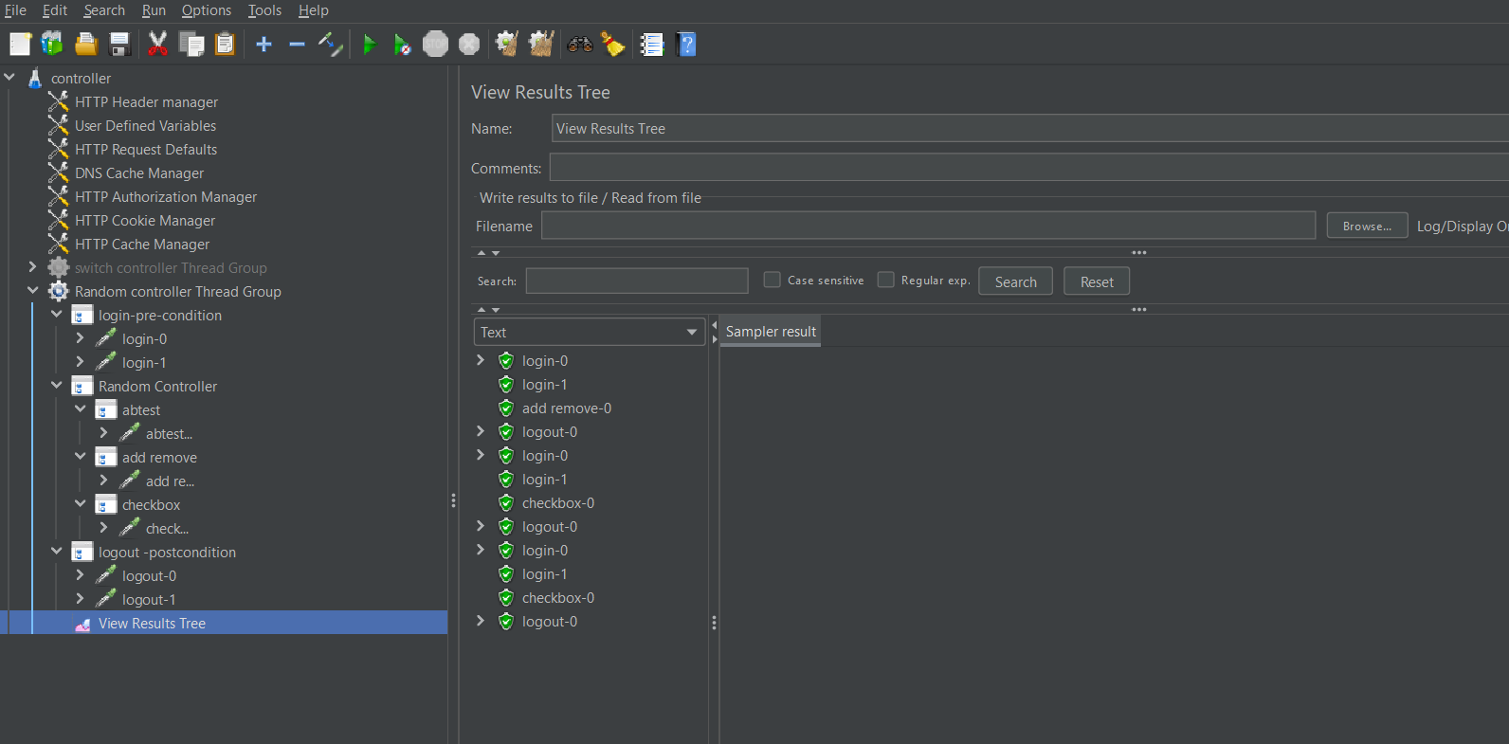

It randomly executes only one script in random controller script.

b) RANDOM ORDER CONTROLLER: -

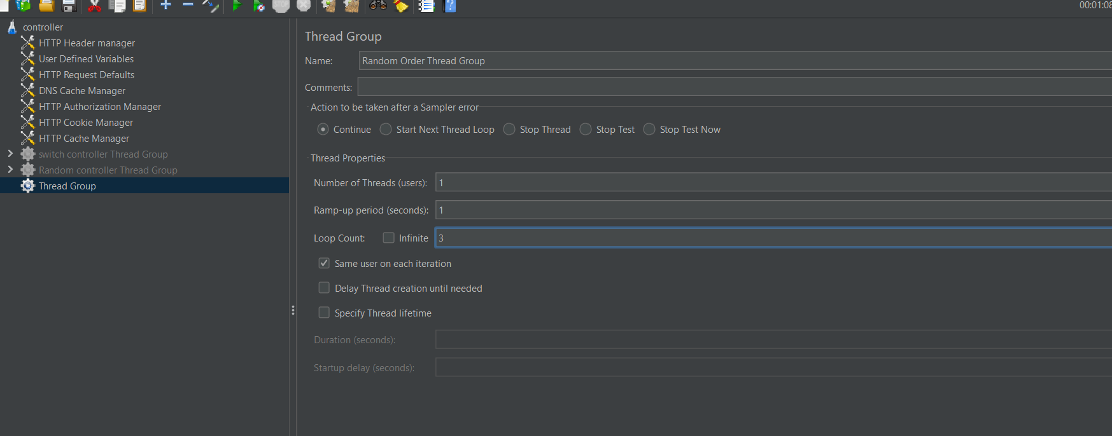

In thread group we gave loop count =03

And name as Random Order Thread Group.

Adding controller to the thread group as given below:-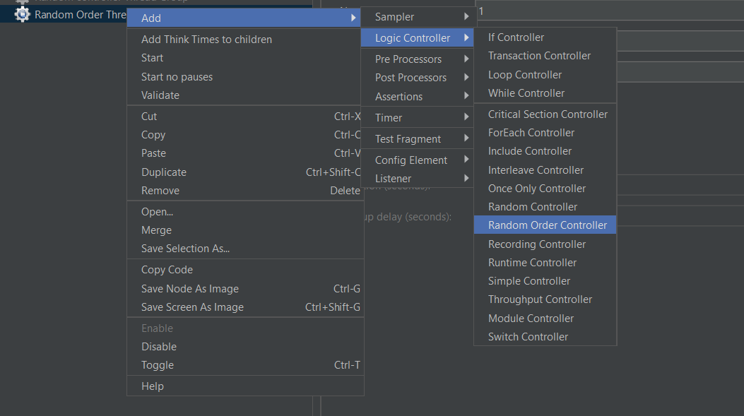

It executed every script in the Random Order controller but not in sequence order.

It executed 3 times.

